Day 2: Basic UML, classes, Object-Oriented programming

Q1: Implement following UML diagram, Write a program to test circle class.

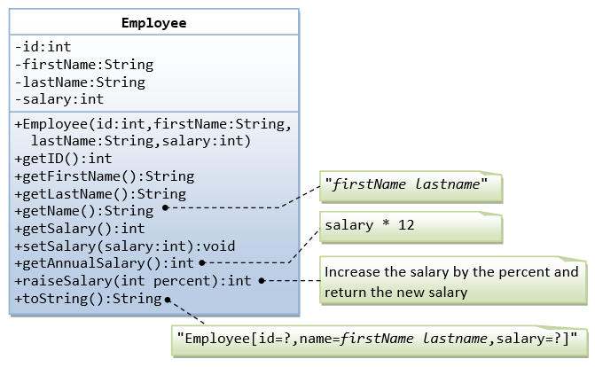

Q2. Create a book store application which will help a book store to keep the record of its books. For each book, the application will have the Book Title, Book Author, Book ISBN along with the number of copies for each book. The system will allow you to display all books, order new/existing books and sell books. With sell or order of existing books, number of copies will decrease/increase. With order of new book, a new book entry will be added to the system.

Here is what you need to do.
1) Create the following Book class.

Book
String bookTitle String author String ISBN
int numOfCopies
Book(String, String, String, int)
void display()

Here is what you need to do.
1) Create the following Book class.
2) display() method will display the book info in “Title – Author – ISBN – Quantity” format.

2) Create another class “BookStore” which should contain all the book objects. For now use an array of Book type and assume you can have maximum 10 different books but each could have multiple copies.

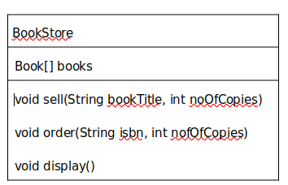

a. sell(String, int) method will search for the book in books array using the bookTitle value. If the book is found in the list, number of copies will decrease. If the book is not found a message should display that book is not found

b. order(String, int) method will order book for the book store. You have to handle both new book and existing book scenario.
i. First search for the book in “books” array using the isbn value.
ii. If the book is found in the list (which means the book already exists in the system), number of copies will increase.
iii. If the book is not found (which means the book does not exists in the system and you need to order new book), a new book entry will be added to the books array.

c. display() method will display info of all books in “books” array “Title – Author – ISBN – Quantity” format. Use Book class’s display() method to display each book’s info.

3) Now create class “BookStoreApp” which should contain the main method. In main method create an object of BookStore class and then Test the different functionality of BookStore

Assignment on Inheritance, Method overriding, Method overloading

Problem#1: A Banking System

Create a Banking System, where a user can create new account, deposit money, withdraw money and check the balance.
For Simplicity, we will create the system for one customer. First the application will require the user to create an account. After creating the account, he should have options to deposit, withdraw money, and check balance as many times as he wants (until he exits the system).

When a user opens/creates an account, he has the option to open a “Saving Account” or a “Current Account”.
See below for the requirements of Current and Savings account.

4) Saving account: A saving account allows user to accumulate interest on funds he has saved for future needs. Interest rates can be compounded on a daily, weekly, monthly, or annual basis. Saving account required a minimum balance. For our purpose let’s assume the minimum balance is 5000 and interest rate is 5% (From savings account, user is only allowed to withdraw a maximum amount of money that available to his account)
5) Current account: Current account offers easy access to your money for your daily transactional needs and helps keep your cash secure. You need a trading license to open a Current account.The have overdraft option with current account

What you need to do:

Create the Account class:
1. This will have name, accountNumber, and accountBalance instance variables;
2. One method name deposit(double).
Create a SavingsAccount class:
1. This class is a subclass of Account class.
2. This will have two additional instance variables
1. One is interest and initialized to 5.
2. Another instance variable for maximum withdraw amount limit(that is equal to amount int the account)
3. Implement getBalance() method.
This method will add the total interest to the accountBalance value and return the value but it won’t change the accountBalance value.

4. Implement withdraw(double) method. This method will allow to withdraw money if the withdraw amount is less than the maximum amount limit and doesn’t set the balance less than minimum balance after withdraw.

Create a CurrentAccount class:
1. Should extend the Account class
2. Add an instance variable tradeLicenseNumber and overdraft
3. Implement getBalance() method. This method will return the accountBalance.
4. Implement withdraw(double) method. This method will allow to withdraw money if the withdraw amount doesn’t exceed the accountBalance value (plus overdraft)

Create the application class “Bank” which will have the main method.

Problem#2: Overloading

Create a Student Class with 3 instance variables for name, id and grade. Create 3 overloaded constructors and 2 overloaded methods.
Constructors:
1. Student(String, String, double) – this will take the name, id and grade as parameter and initialize.
2. Student(String, String) – this will take the name and id as parameter and initialize.
3. Student(String) – this will take the id as parameter and initialize.

Note: For constructor, invoke the first constructor in the other 2. Similarly invoke/call display() in display(int) method.

Methods:
1. display() – will display the name, id, grade if they have a value.
2. display(int) – will take the current year of the student as parameter and display the name, id, grade and in which year the if they have a value.

Now implement the application class that will have the main method.
From main method, you have to provide a menu on the console. It will take user input to create the object using one of the 3 constructors. Which constructor you have to use depends on what info user has provided e.g. if user just provide id, you have to call Student(String) and so on. Do similar logic for option 2/display.
‘1’ – to create a Student object. ‘2’ – to display the student info.

Problem#3: Overriding
Here are the 4 Java classes you need to implement. Car class inherits Vehicle class. Convertible and
SportCar are descendent of Car class.

Now implement the application class that will have the main method. From main method, you have to provide a menu on the console. It will take user input to create specific type [one of the 4 classes above] of object of and call the display method.

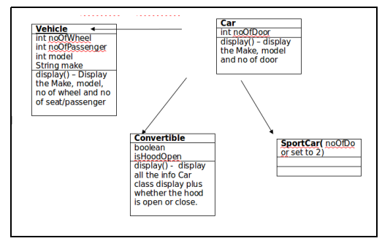

‘1’– to create a Convertible object.
‘2’– to create a SportCar object.

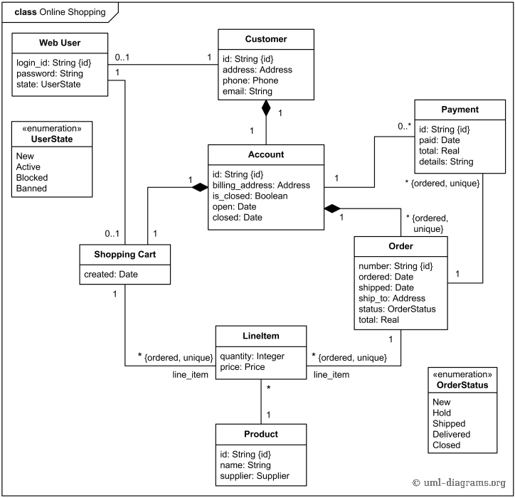
Problem 4: Study following uml diagram and find out relationship between different objects

